**TV Shows Assignment**

Television shows have long been a staple of entertainment, captivating audiences with compelling narratives, engaging characters, and thought-provoking themes. Over the years, the landscape of television has evolved dramatically, reflecting the shifting tastes and preferences of viewers. From the early days of black-and-white classics to the modern era of streaming platforms, TV shows have consistently left an indelible mark on popular culture.

Throughout history, certain TV shows have risen above the rest, achieving unprecedented levels of success and popularity. These shows have not only entertained audiences but also sparked discussions, influenced fashion and lifestyle trends, and even shaped societal norms.

In this assignment, we will delve into a comprehensive analysis of the top 250 TV shows, exploring various facets such as IMDb ratings, release years, genres, certificates, and durations. By dissecting these aspects, we aim to gain valuable insights into the factors contributing to the success and popularity of television shows across different genres and time periods.

**TV shows in the top 250 have a rating above 9**

As we can observe from the below charts (chart 1 and 2), there are total 31 shows with rating above 9. Most of the time shows with genre “Documentary” were rated above 9. As per the above chart, 7 shows from Genre “Documentary” obtained a rating of above 9.

**Chart 1**

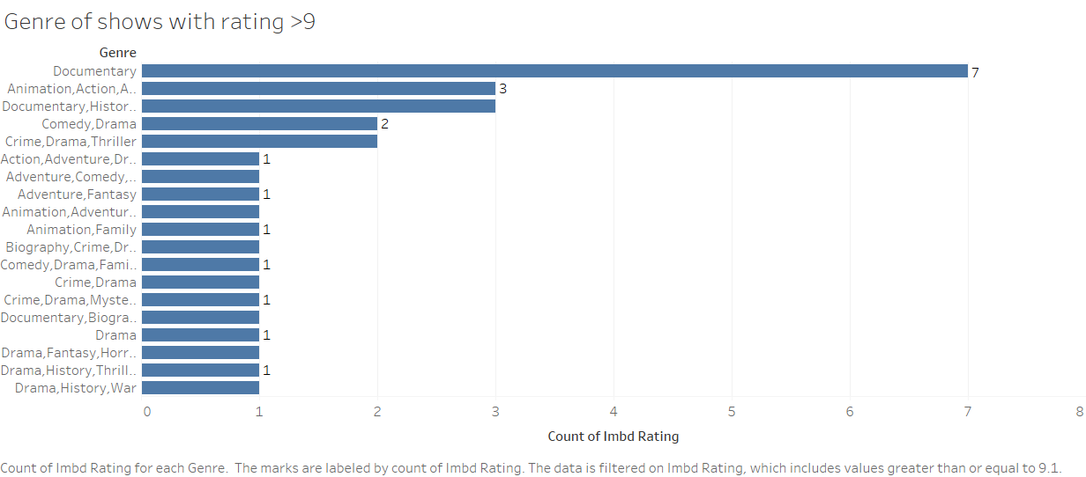

**Chart 2**

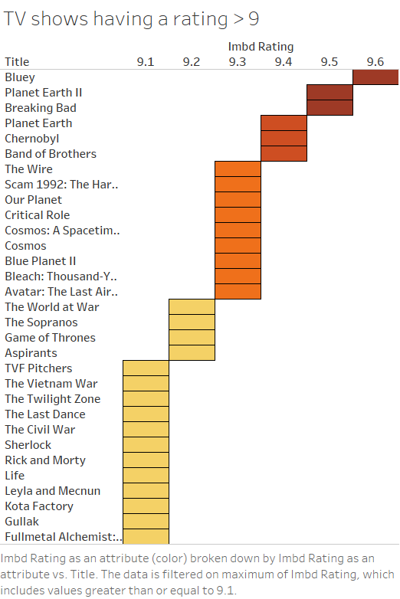

**Year with the highest number of TV shows**

It can be observed from the below chart that year 2015 has the maximum number of shows (n=15). The chart also indicates an overall per year increase in number of shows.

**Chart 3**

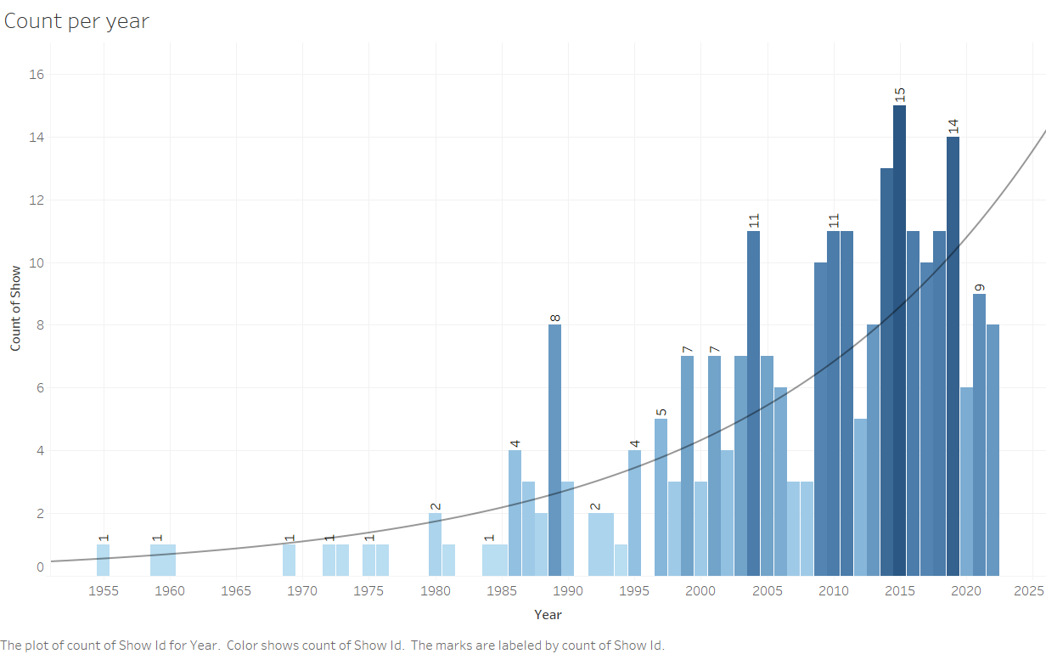

**Distribution of TV show genres**

The dataset reveals a diverse range of TV show genres, with Animation, Action, Adventure being the most prevalent category, encompassing 33 TV shows. Following this, Comedy stands out with 30 TV shows exclusively belonging to this genre. Furthermore, various combinations of genres are evident, with Crime, Drama, Mystery and Crime, Drama, Thriller being the most common, each accounting for 17 and 13 TV shows respectively. Chart 4 below provides insights into the distribution of TV show genres within the dataset.

**Chart 4**

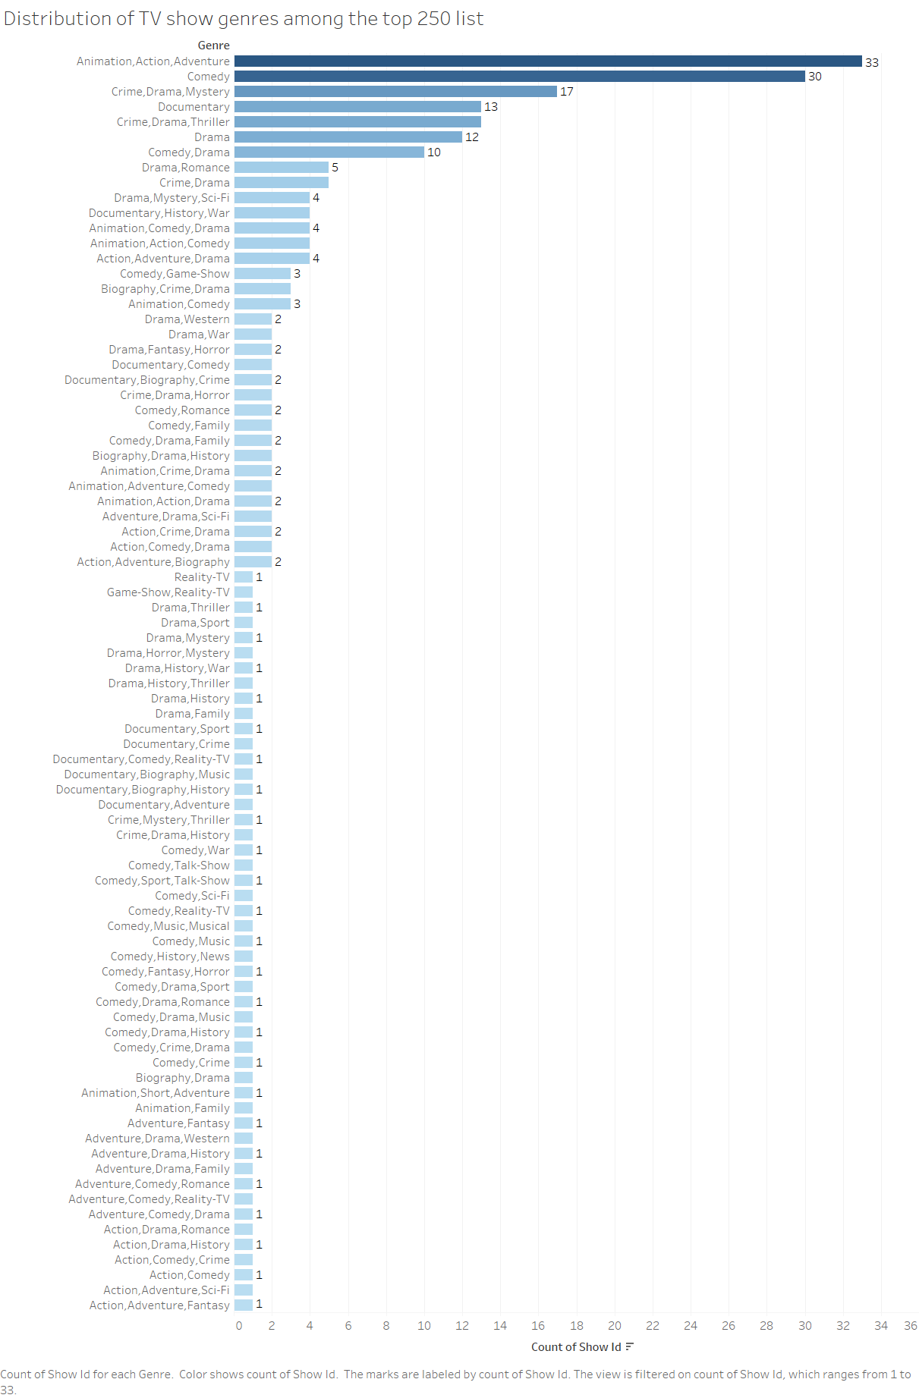

**Genre with highest number of average IMDB votes**

The Chart 5 below shows the average number of IMDB votes for TV shows within the top 250 list, segmented by genre. Among these genres, Action, Adventure, Drama emerges as the most popular category, boasting the highest average number of IMDB votes per TV show at approximately 654k. Following closely is Drama, Fantasy, Horror with an average of approximately 635k votes, indicating a strong viewer engagement with this genre combination. Comedy, Romance also commands significant attention, garnering an average of approximately 521k votes per TV show. Meanwhile, Animation, Adventure, Comedy secures a respectable position with an average of approximately 381k votes. Crime, Drama and Drama, Mystery, Sci-Fi follow suit with average votes of approximately 338k and 332k respectively. Crime, Drama, Thriller and Action, Crime, Drama genres exhibit slightly lower average vote counts, with approximately 278k and 272k votes per TV show respectively. Animation, Comedy rounds off the list with an average of approximately 271k votes.

**Chart 5**

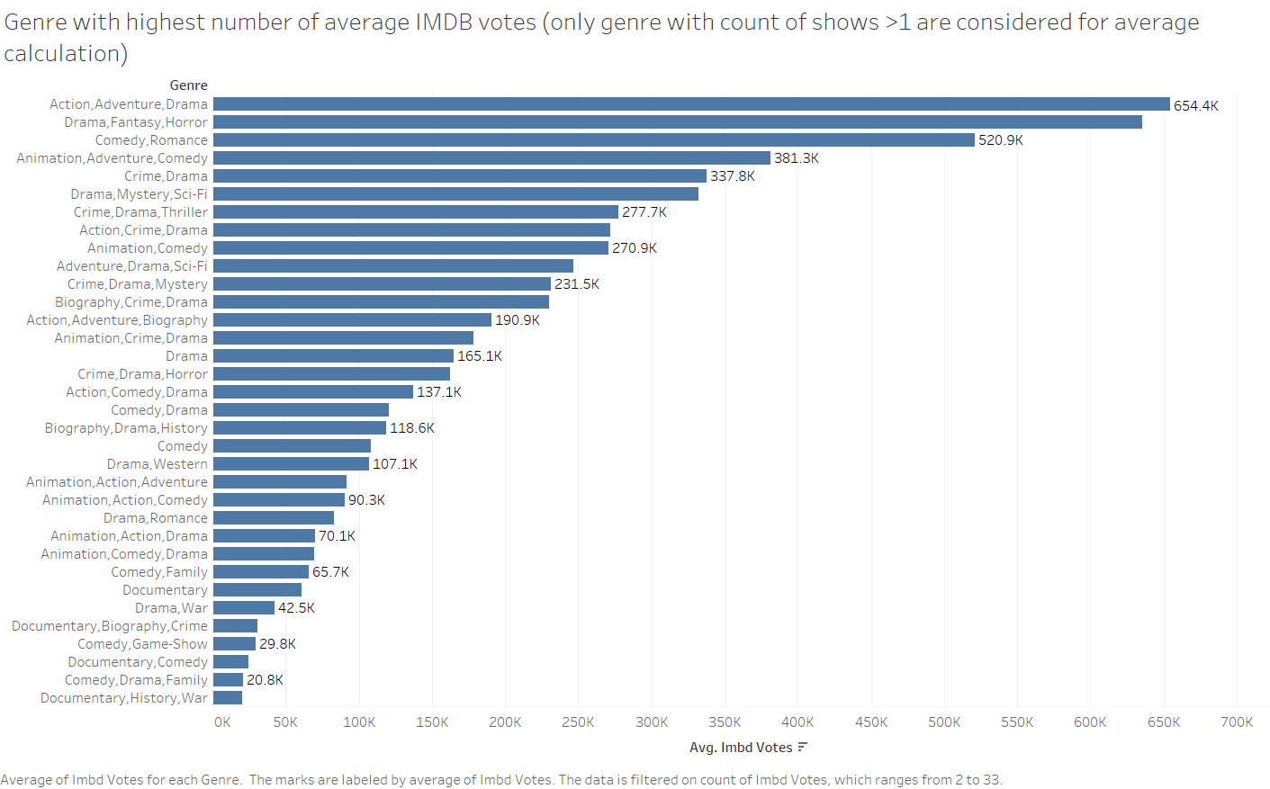

**Distribution of TV show certificates**

The pie chart below (Chart 6) provides insights into the distribution of TV show certificates within the top 250 list. Among these certificates, TV-MA emerges as the most prevalent, with 110 TV shows falling under this category. Following closely is TV-14, with 73 TV shows receiving this certificate. TV-PG also commands a notable presence, with 47 TV shows carrying this certification. Additionally, TV-G is represented by 7 TV shows, while Not Rated has 3 TV shows. TV-Y7-FV and TV-Y7 each have 2 TV shows, and TV-Y and PG-13 are represented by 1 TV show each. In summary, the dataset illustrates a varied distribution of TV show certificates within the top 250 list, showcasing the diverse range of content ratings among the top-ranked TV shows.

**Chart 6**

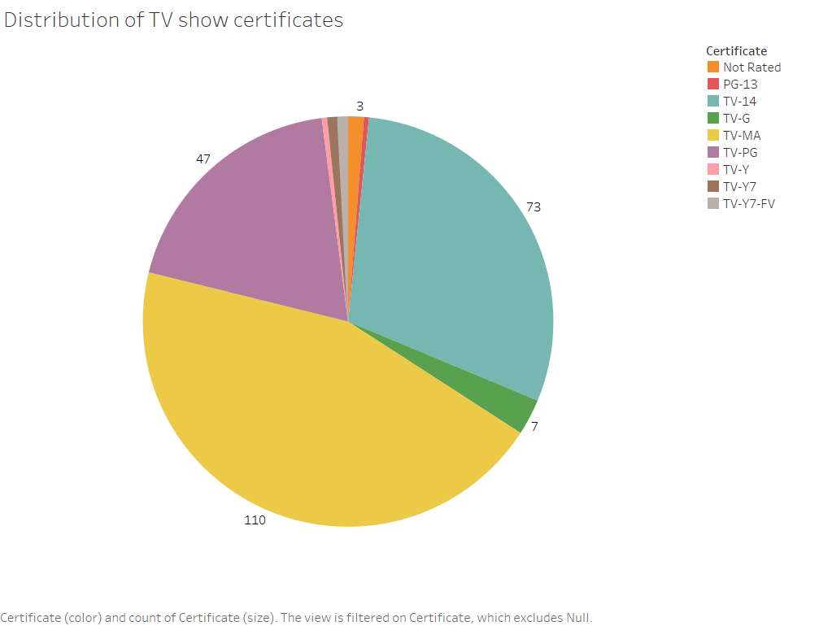

**Distribution of TV show duration**

The Chart 7 below provides insights into the distribution of TV show durations within the top 250 list. Among these durations, the most prevalent is 1 hour, with 30 TV shows falling into this category. Following closely is the duration of 30 minutes, represented by 29 TV shows. Additionally, 24 minutes and 22 minutes durations are also notable, with 24 TV shows and 18 TV shows respectively. Other durations include 25 minutes and 23 minutes, each represented by 12 TV shows. Furthermore, durations of 45 minutes, 55 minutes, and 44 minutes are each represented by 11 TV shows and 9 TV shows respectively. In summary, the dataset showcases a diverse distribution of TV show durations within the top 250 list, highlighting the range of time formats among the top-ranked TV shows.

**Chart 7**

